Name: Tukaram Balaji Tadmadge

1.HTML
1. <!DOCTYPE html>
<html lang="en">
<head>
<meta charset="UTF-8">
<title>My Website</title>
<style>
body {
font-family: Arial, sans-serif;
margin: 40px;
}

h1, h2 {
font-weight: bold;
}

table {
margin-top: 10px;
margin-bottom: 20px;
}

td {
padding: 5px 15px;
}

form input, form textarea {
margin-bottom: 10px;
display: block;
}
</style>
</head>
<body>

<!-- Semantic Header -->
<header>
<h1>Welcome to my website!</h1>
<p>This is the home page of my website.</p>
</header>

<!-- Semantic Section -->
<section>
<h2>About Me</h2>
<p>My name is John Doe and I'm a web developer.</p>

<!-- Non-semantic div -->
<div>
<ol>
<li>HTML5</li>
<li>CSS3</li>
<li>JavaScript</li>
</ol>
</div>

<!-- Table Layout -->
<table border="1">
<tr>
<td>Row 1, Column 1</td>
<td>Row 1, Column 2</td>
</tr>
<tr>
<td>Row 2, Column 1</td>
<td>Row 2, Column 2</td>
</tr>
</table>
</section>

<!-- Semantic Section -->
<section>
<h2>Contact Me</h2>

<!-- Form (Non-semantic container used) -->
<div>
<form>
<label>Name:</label>
<input type="text" name="name">

<label>Email:</label>
<input type="email" name="email">

<label>Message:</label>
<textarea rows="4" cols="30"></textarea>

<input type="submit" value="Send">
</form>
</div>
</section>

<!-- Footer -->
<footer>
<p>Write some content here</p>
<p>write Some more content here</p>
</footer>

</body>
</html>

Output:

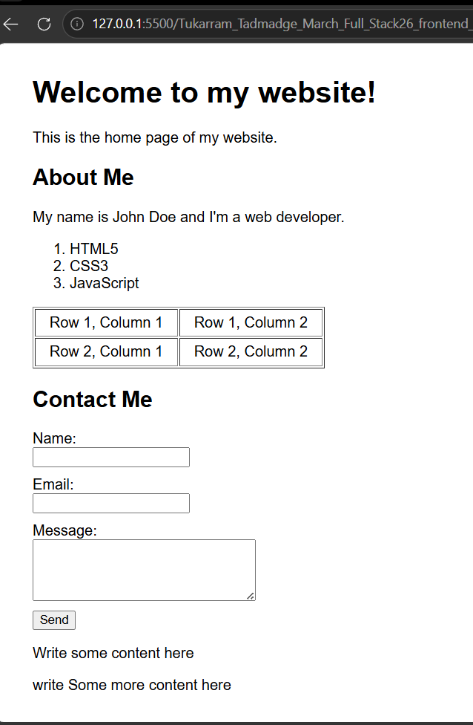

2. <!DOCTYPE html>
<html>

<head>
<title>Menu Card</title>
</head>

<body style="background-color:#111; color:white; font-family:Arial;">

<h2 style="text-align:center; background-color:yellow; color:black; padding:10px;">
MENUCARD
</h2>

<table border="2" width="100%" cellspacing="10" cellpadding="10"
style="background-color:black; border-color:yellow;">

<tr>

<td>
<h3 style="text-align:center; color:yellow;">PURE VEG</h3>
<img src="https://cdn.pixabay.com/photo/2017/01/26/02/06/indian-food-2009590_640.jpg" width="100%"
height="150">

<table border="1" width="100%" style="color:yellow; border-color:yellow;">
<tr>
<th>Menu</th>
<th>Price</th>
</tr>
<tr>
<td>Mutter Paneer</td>
<td>200</td>
</tr>
<tr>
<td>Shahi Paneer</td>
<td>220</td>
</tr>
<tr>
<td>Kaju Masala</td>
<td>250</td>
</tr>
<tr>
<td>Palak Paneer</td>
<td>180</td>
</tr>
<tr>
<td>Veg Kolhapuri</td>
<td>160</td>
</tr>
</table>
</td>

<td>
<h3 style="text-align:center; color:yellow;">BREAD'S</h3>
<img src="breads.jpg" width="100%" height="150">

<table border="1" width="100%" style="color:yellow; border-color:yellow;">
<tr>
<th>Menu</th>
<th>Price</th>
</tr>
<tr>
<td>Tandoori Roti</td>
<td>20</td>
</tr>
<tr>
<td>Lachha Paratha</td>
<td>30</td>
</tr>
<tr>
<td>Butter Naan</td>
<td>25</td>
</tr>
<tr>
<td>Roomali Roti</td>
<td>10</td>
</tr>
<tr>
<td>Aloo Paratha</td>
<td>50</td>
</tr>
</table>
</td>

<td>
<h3 style="text-align:center; color:yellow;">NON-VEG</h3>
<img src="https://cdn.pixabay.com/photo/2018/06/18/16/05/indian-food-3482749_640.jpg" width="100%"
height="150">

<table border="1" width="100%" style="color:yellow; border-color:yellow;">
<tr>
<th>Menu</th>
<th>Price</th>
</tr>
<tr>
<td>Butter Chicken</td>
<td>350</td>
</tr>
<tr>
<td>Kadai Chicken</td>
<td>250</td>
</tr>
<tr>
<td>Chicken Curry</td>
<td>300</td>
</tr>
<tr>
<td>Fish Curry</td>
<td>400</td>
</tr>
<tr>
<td>Egg Curry</td>
<td>150</td>
</tr>
</table>
</td>

</tr>

<tr>

<td>
<h3 style="text-align:center; color:yellow;">RICE</h3>
<img src="https://cdn.pixabay.com/photo/2017/06/02/18/24/rice-2367029_640.jpg" width="100%"
height="150">

<table border="1" width="100%" style="color:yellow; border-color:yellow;">
<tr>
<th>Menu</th>
<th>Price</th>
</tr>
<tr>
<td>Jeera Rice</td>
<td>130</td>
</tr>
<tr>
<td>Veg Pulao</td>
<td>150</td>
</tr>
<tr>
<td>Plain Rice</td>
<td>90</td>
</tr>
<tr>
<td>Biryani</td>
<td>150</td>
</tr>
<tr>
<td>Tawa Pulao</td>
<td>100</td>
</tr>
</table>
</td>

<td>
<h3 style="text-align:center; color:yellow;">CHINESE</h3>
<img src="chines.jpg" alt="" width="100%" height="150">

<table border="1" width="100%" style="color:yellow; border-color:yellow;">
<tr>
<th>Menu</th>
<th>Price</th>
</tr>
<tr>
<td>Noodles</td>
<td>140</td>
</tr>
<tr>
<td>Manchurian</td>
<td>130</td>
</tr>
<tr>
<td>Fried Rice</td>
<td>100</td>
</tr>
<tr>
<td>Schezwan Noodles</td>
<td>160</td>
</tr>
<tr>
<td>Chicken Soup</td>
<td>170</td>
</tr>
</table>
</td>

<td>
<h3 style="text-align:center; color:yellow;">SOUTH INDIAN</h3>
<img src="south.jpg" alt="" width="100%" height="150">

<table border="1" width="100%" style="color:yellow; border-color:yellow;">
<tr>
<th>Menu</th>
<th>Price</th>
</tr>
<tr>
<td>Plain Dosa</td>
<td>35</td>
</tr>
<tr>
<td>Masala Dosa</td>
<td>45</td>
</tr>
<tr>
<td>Vada Sambar</td>
<td>40</td>
</tr>
<tr>
<td>Idli Sambar</td>
<td>50</td>
</tr>
<tr>
<td>Uttapa</td>
<td>70</td>
</tr>
</table>
</td>

</tr>

</table>

</body>

</html>

Output: 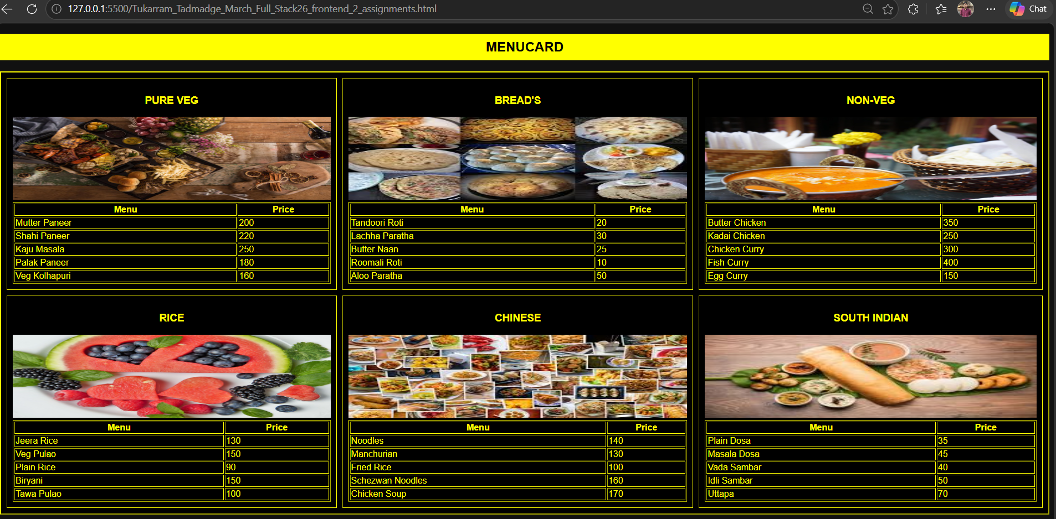
3

3. <!DOCTYPE html>
<html>
<head>
<title>Form Input Controls</title>
</head>

<body style="font-family: Arial; margin: 40px;">

<h2>Form Input Controls Example</h2>

<form>

<!-- Basic Inputs -->
Name: <input type="text" placeholder="Enter your name">

Password: <input type="password" placeholder="Enter your password">

Email: <input type="email" placeholder="Enter your email">
<br><br>

Age: <input type="number" value="18">

Rating: <input type="range">

Date of Birth: <input type="date">
<br><br>

Time: <input type="time">

Image: <input type="file">
<br><br>

Week: <input type="week">
<br><br>

Month: <input type="month">
<br><br>

Datetime-Local: <input type="datetime-local">
<br><br>

URL: <input type="url">
<br><br>

Search: <input type="search">
<br><br>

<!-- Radio Buttons -->
Gender:<br>
<input type="radio" name="gender" checked> Male
<input type="radio" name="gender"> Female
<br><br>

<!-- Checkboxes -->
Interests:<br>
<input type="checkbox"> Reading
<input type="checkbox" checked> Sports
<br><br>

<!-- Dropdown -->
Country:
<select>
<option>United States</option>
<option>India</option>
<option>UK</option>
</select>
<br><br>

<!-- Textarea -->
Message:<br>
<textarea rows="4" cols="40" placeholder="Enter your message"></textarea>
<br><br>

<!-- Submit -->
<input type="submit" value="Submit">

</form>

</body>
</html>

Output:

: 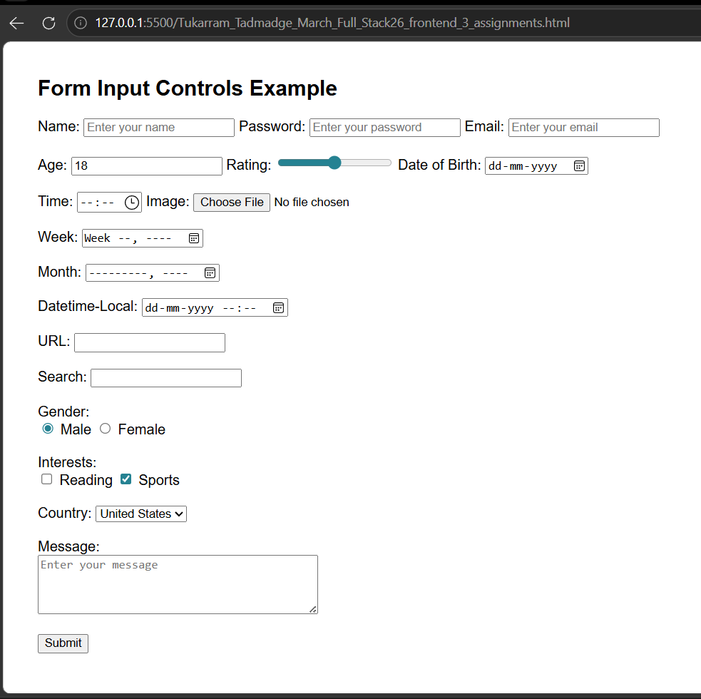

4

4
<!DOCTYPE html>
<html>
<head>
<title>Flipkart Login</title>
</head>

<body style="margin:0; font-family: Arial; background:#f1f3f6;">

<div style="width:700px; height:400px; margin:80px auto; display:flex; box-shadow:0 0 10px gray;">

<!-- LEFT PANEL -->
<div style="width:40%; background:#2874f0; color:white; padding:30px; position:relative;">

<h2>Login</h2>
<p style="font-size:14px;">
Get access to your Orders,<br>
Wishlist and Recommendations
</p>

<!-- Fixed Image -->
<img src="https://cdn-icons-png.flaticon.com/512/5087/5087579.png"
style="width:150px; position:absolute; bottom:20px; left:30px;">
</div>

<!-- RIGHT PANEL -->
<div style="width:60%; background:white; padding:30px;">

<input type="text" placeholder="Enter Email/Mobile number"
style="width:100%; padding:10px; margin-bottom:20px; border:1px solid #ccc;">

<p style="font-size:12px; color:gray;">
By continuing, you agree to Flipkart's
<span style="color:#2874f0;">Terms of Use</span> and
<span style="color:#2874f0;">Privacy Policy</span>.
</p>

<button style="width:100%; padding:12px; background:#fb641b; color:white; border:none; margin-top:15px;">
Request OTP
</button>

<p style="text-align:center; margin-top:40px; font-size:14px;">
New to Flipkart?
<span style="color:#2874f0;">Create an account</span>
</p>

</div>

</div>

</body>
</html>

Output: 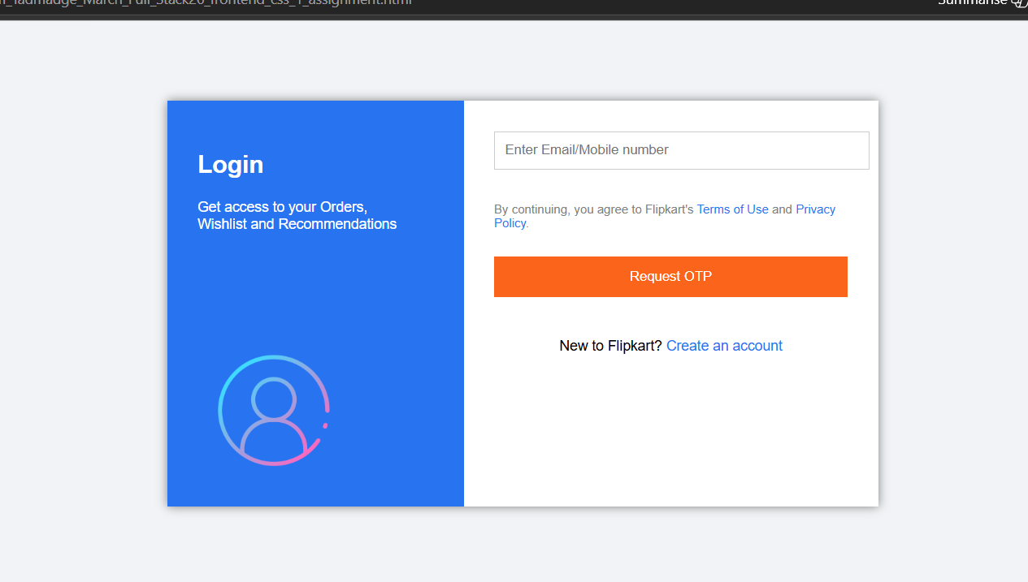

5.
<!DOCTYPE html>
<html>
<head>
<title>Flexbox Properties</title>

<style>
body {
margin: 0;
font-family: Arial;
background: linear-gradient(to right, pink, purple);
}

.row {
display: flex;
justify-content: space-evenly;
align-items: center;
padding: 30px;
}

.row2 {
display: flex;
justify-content: space-evenly;
align-items: center;
padding: 80px 30px;
}

.container {
width: 140px;
height: 140px;
background: linear-gradient(orange, yellow);
display: flex;
border: 2px solid black;
}

.box {
width: 35px;
height: 35px;
background: linear-gradient(blue, cyan);
border: 1px solid black;
text-align: center;
font-size: 10px;
}

.start { justify-content: flex-start; }
.center { justify-content: center; }
.end { justify-content: flex-end; }

.between {
justify-content: space-between;
gap: 5px;
}

.around {
justify-content: space-around;
gap: 5px;
}

.evenly {
justify-content: space-evenly;
gap: 5px;
}

.align-center { align-items: center; }
.align-end { align-items: flex-end; }

.both-center {
justify-content: center;
align-items: center;
}

.both-end {
justify-content: flex-end;
align-items: flex-end;
}
</style>

</head>

<body>

<div class="row">

<div class="container start">
<div class="box">Box1</div>
<div class="box">Box2</div>
<div class="box">Box3</div>
</div>

<div class="container center">
<div class="box">Box1</div>
<div class="box">Box2</div>
<div class="box">Box3</div>
</div>

<div class="container end">
<div class="box">Box1</div>
<div class="box">Box2</div>
<div class="box">Box3</div>
</div>

<div class="container between">
<div class="box">Box1</div>
<div class="box">Box2</div>
<div class="box">Box3</div>
</div>

<div class="container around">
<div class="box">Box1</div>
<div class="box">Box2</div>
<div class="box">Box3</div>
</div>

<div class="container evenly">
<div class="box">Box1</div>
<div class="box">Box2</div>
<div class="box">Box3</div>
</div>

</div>

<div class="row2">

<div class="container align-center">
<div class="box">Box1</div>
<div class="box">Box2</div>
<div class="box">Box3</div>
</div>

<div class="container align-end">
<div class="box">Box1</div>
<div class="box">Box2</div>
<div class="box">Box3</div>
</div>

<div class="container both-center">
<div class="box">Box1</div>
<div class="box">Box2</div>
<div class="box">Box3</div>
</div>

<div class="container both-end">
<div class="box">Box1</div>
<div class="box">Box2</div>
<div class="box">Box3</div>
</div>

</div>

</body>
</html>

Output: 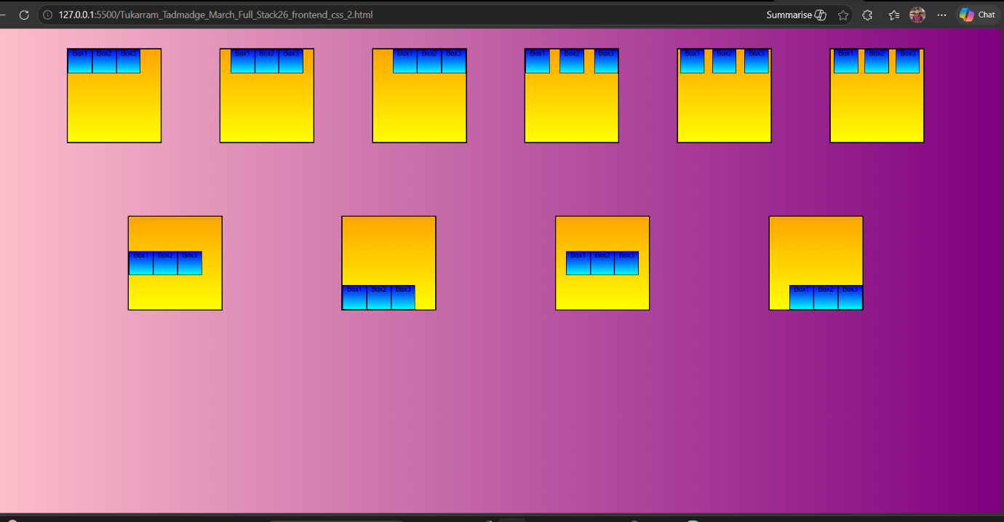

6. <!DOCTYPE html>

<html>
<head>
<title>Grid Layout</title>

<style>
body {
margin: 0;
font-family: Arial;
}

.container {
display: grid;
grid-template-areas:
"header header"
"sidebar main"
"footer footer";
grid-template-columns: 200px 1fr;
grid-template-rows: 80px 300px 60px;
}

.header {
grid-area: header;
background: #333;
color: white;
text-align: center;
line-height: 80px;
font-size: 20px;
}

.sidebar {
grid-area: sidebar;
background: #f2f2f2;
padding: 10px;
}

.main {
grid-area: main;
background: #ffffff;
padding: 10px;
}

.footer {
grid-area: footer;
background: #333;
color: white;
text-align: center;
line-height: 60px;
}
</style>

</head>

<body>

<div class="container">

<div class="header">Header</div>

<div class="sidebar">
<b>Sidebar</b><br>
The Menu or quick access content.
</div>

<div class="main">
<b>Main Content</b><br>
The main website content should be displayed here.
</div>

<div class="footer">Footer</div>

</div>

</body>
</html>

Output: 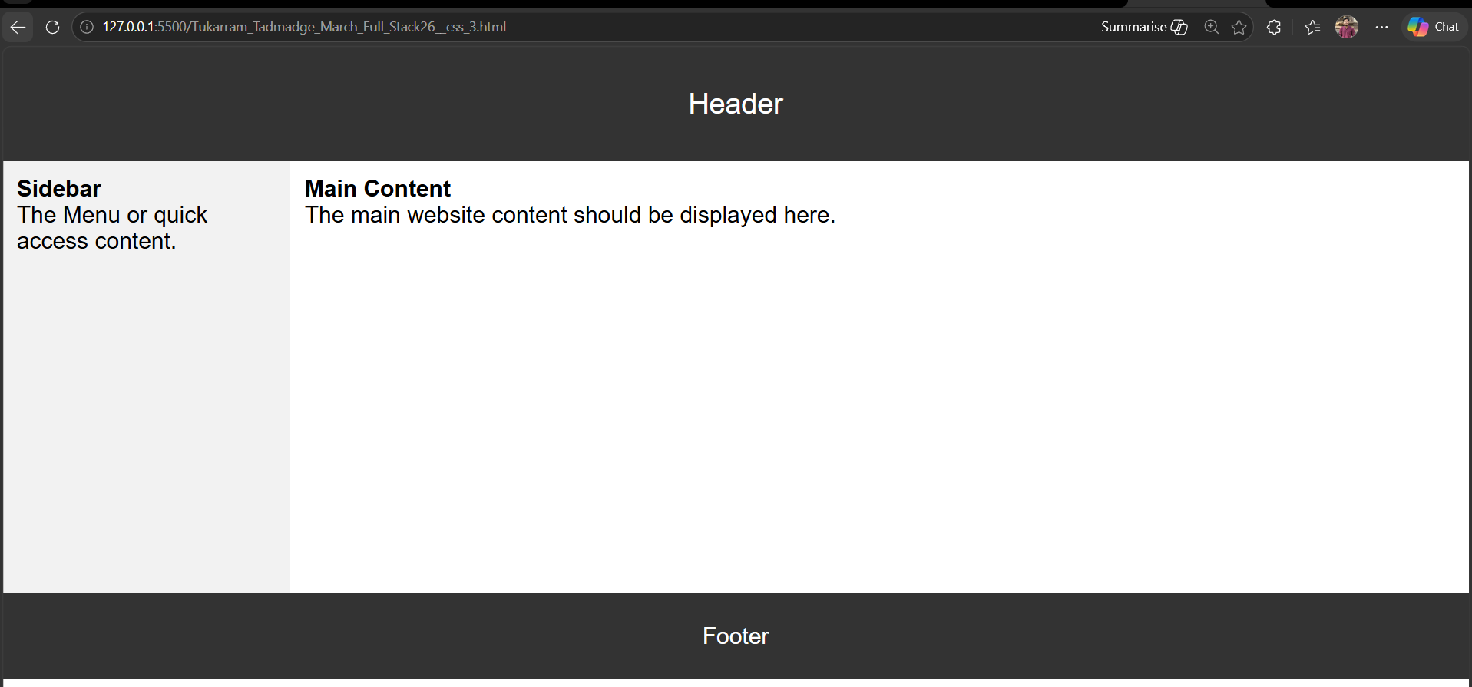

7.
<!DOCTYPE html>
<html>
<head>
<title>JavaScript Loops, Operators and Conditions</title>
</head>
<body>

<h2>Open Console to See Output</h2>

<script>

// Operators and Conditions
let num1 = 20;
let num2 = 10;

if (num1 > num2) {
console.log("Num1 is greater");
} else {
console.log("Num2 is greater");
}

// While Loop
let i = 1;

while (i <= 5) {
console.log("While loop iteration " + i);
i++;
}

// For Loop
for (let j = 1; j <= 5; j++) {
console.log("For loop iteration " + j);
}

// Do-While Loop
let k = 1;

do {
console.log("Do-While loop iteration " + k);
k++;
} while (k <= 5);

// Switch Condition
let day = 1;

switch(day) {
case 1:
console.log("It's Monday");
break;

case 2:
console.log("It's Tuesday");
break;

default:
console.log("Invalid Day");
}

</script>

</body>
</html>

Output: 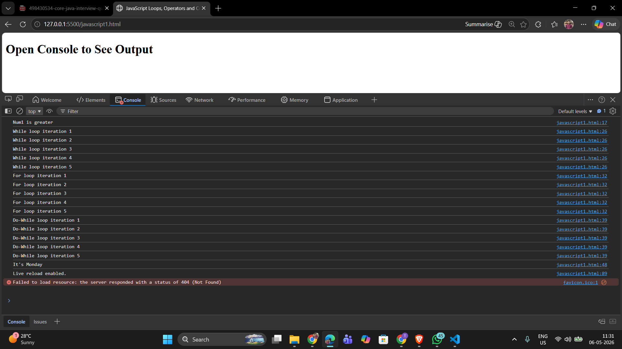
8

8. <!DOCTYPE html>
<html>
<head>
<title>Bulb ON/OFF using DOM</title>

<style>

body{
display: flex;
justify-content: center;
align-items: center;
height: 100vh;
background-color: #f2f2f2;
}

.container{
text-align: center;
}

#bulb{
width: 250px;
height: 250px;
border: 2px solid black;
border-radius: 50%;
background-color: white;
margin-bottom: 30px;
}

button{
width: 60px;
height: 50px;
font-size: 18px;
margin: 10px;
cursor: pointer;
}

</style>
</head>

<body>

<div class="container">

<div id="bulb"></div>

<button onclick="bulbOn()">ON</button>

<button onclick="bulbOff()">OFF</button>

</div>

<script>

// Function for ON button
function bulbOn(){

let color = prompt("Enter bulb color");

document.getElementById("bulb").style.backgroundColor = color;
}

// Function for OFF button
function bulbOff(){

document.getElementById("bulb").style.backgroundColor = "white";
}

</script>

</body>
</html>

Output: 